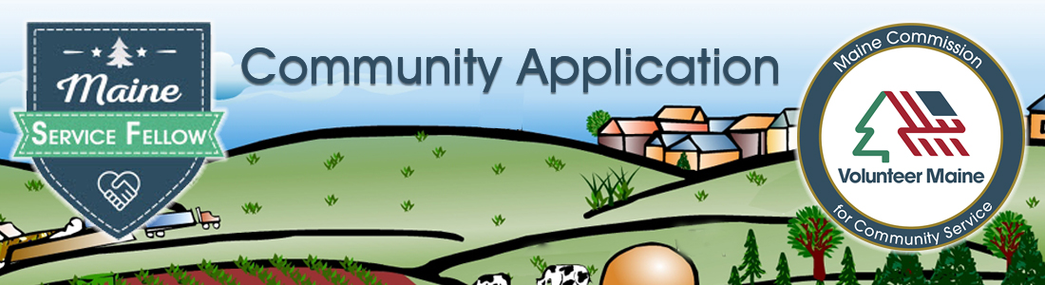
APPLICANT INFO
Contact info:
Name of person submitting proposal, email, phone

Organization:
Name, Address, website, EIN

Does your organization have an audit? Yes/No
If yes, how often and who does it?
If no, 1) who reviews agency financial reports and how often?
Does your organization file a 990 or other public annual financial report?

What type of organization?
- Nonprofit  - State, county or local government  - Educational institution  - Faith-based organization | - Tribal government  - Regional organization  - Other

Documents required with application.
- A staff organizational chart
- List of governing board members, county commissioners, town council members (whatever is applicable)
- Proof of organizational eligibility (IRS letter with tax exempt status OR W9)

Select the county or counties served by this project:
 | Aroostook County |  | Oxford County |  | Piscataquis County
 | Franklin County |  | Penobscot County |  | Somerset County
 | Hancock County |  | Knox County |  | Waldo County
 | Kennebec County |  | Lincoln County

PROJECT FOCUS AREA (choose the one most applicable to the project):
General areas  - COVID 19 recovery  - Housing, including eviction prevention  - Workforce development  - Substance use prevention and recovery  - Public health issues, including mental health | Climate action areas  - Coastal zone  - Community resilience (including climate action planning)  - Transportation  - Energy  - Housing  - Land and fresh-water preservation  - Education (k-12 and community)  - Public health

Narratives. In this section we are trying to get to know you from a distance. You can be brief and to the point. The selection committee only wants to read 6 pages work plan. The content of the narratives appears below. The percentages shown for each section indicate the weight the committee will give to the information provided.

PROJECT OVERVIEW (30%)
- Within the focus area you selected, what is the community need the Maine Service Fellow will address? Provide evidence the need exists in the community or communities that will benefit.
- If the project is successful, what will be different?
- Please name the communities involved and describe them using census demographic information and any economic or other descriptive information you have.
- Who identified this need as important to address? Describe the role any organizations, resident committees, or local government played in this process.
- Are any nonprofits, government offices, civic groups, coalitions, or businesses doing any work now to address the issue? If yes, please give an overview. If not, please note any of local entities who are (or might be) interested in tackling the issue as partners with you.
- Why is a Maine Service Fellow the right resource for this project? How will their service advance the goals of your organization and be distinct from other staff or volunteer roles?

ORGANIZATIONAL BACKGROUND (20%)
Organizational Overview
- What is your organization’s mission and geographic area(s) served?
- What current programs and services does your organization provide?
- With what organizations does your agency already partner? Please give examples of joint projects or services.
- What is your organization’s experience with managing volunteers or interns? What is the most important work volunteers or interns have done for your agency recently?

SERVICE FELLOW SUPERVISION & SUPPORT PLAN (30%)
Service Fellows will need training, support, and guidance to be successful. They are being recruited to complete a term of service that benefits your organization/community. The “other side of the coin” is what the community provides to the Service Fellow in terms of training, mentoring, networking, and professional development opportunities.

Remember there are two roles the local project needs to fill. One is the technical supervisor who guides, trains, and supervises the Service Fellow’s activities related to the project and work plan. The second role is a community liaison whose job is to help the person explore those things in your community that would foster a connection and understanding of the people and place. This also helps the person stay physically and mentally healthy.

Use this section to demonstrate that your organization is ready to support the unique needs of the Service Fellow and the project.

Service Fellow Requirements
- What background, education, or training should the Service Fellow have to in order to succeed on the project?
- What orientation and training related to your specific project and community will the person need? Who will provide that to the Service Fellow? Does your agency have any industry-specific requirements, laws, or organizational policies that the Service Fellow would have to comply with? (E.g., confidentiality, record handling, safety protocols).
- Can you provide other professional development opportunities, support, and/or benefits to the Service Fellows?
- What personal opportunities, support, and/or benefits can the community liaison connect the Service Fellow to, in order to foster a community social network?

Service Fellow Supervision & Mentorship
- Who will be the Service Fellow’s technical supervisor (at the work site)? What is their role in the organization? What experience does the person have in mentoring and supervising interns, volunteers, or new staff? How has the person been involved in the development of this application/project?
- Is the supervisor based 100% in the same location as Service Fellows?
- Describe the physical workspace that will be provided to the Service Fellow(s). How will you ensure that Service Fellows are provided with adequate workspace, supplies, and resources to be successful in their service?
- Who will be the Service Fellow’s community liaison? Please give some background about the person. How was the person identified? What experience does the person have in a comparable role? How has the person been involved in the development of this application/project?

PROJECT PLAN in (20% – complete and submit attachment format)
Proposed projects that address a clear, unmet community need with a well-designed set of activities and measurable, meaningful outcomes will be given preference. Complete the work plan template in the Attachments section. It is intended to be a stand-alone summary that will be shared with applicants for Maine Service Fellows positions. Upload the saved word doc at the end of the online form to complete your application.

An example is given in the text below. It is solely for inspiration on how to express your project. There are descriptions for each field and column of the logic model in the text that follows.

Project Name:
- What will you call the project the Service Fellow will work on?
- Example. XYZ Agency Displaced Worker Retraining Project
Sponsor Organization:
- The entity submitting this application
Assignment Location:
- The town where the person’s office will be and where they are likely to live during service.
Project Beneficiaries (target population):
- Who will benefit from this project?
- Example. Displaced workers who live in XYZ.
Community Need: [for committee – this summary lets the workplan stand alone so it can be shared with MSF applicants and others but it does not give the sense of scale/scope/location the narrative provides]
- Enter a brief (no more than 15 words) summary of the need described earlier.
- Example. Displaced workers need new job skills to obtain employment.

Project goal:
- What is the ultimate purpose for the project activities? Be terse – about 12 words.
- Examples. Launch job retraining and readiness program for displaced mill workers.

Project Activities:
- Describe the activities the Service Fellow will conduct while in service to this project. Think of the activity sequence as First Quarter (first activities the Fellow will do) through Fourth Quarter (wrap up of the service year). If it helps, use a code like the one below.
- Examples.
- Q1 Develop project advisory committee that includes displaced worker representatives, potential employers, economic development leader, local government representative, chamber of commerce.
- Q1 Assess skills needed for locally available jobs or jobs that can be done by remote workers.
- Q2 Identify opportunities and barriers to matching displaced workers with employment opportunities.
- Q2 Assess interests and plans of displaced workers.
- Q3 Identify sources of funds and training programs that match skills identified.
- Q4 Launch pilot retraining program

Attachment A: Project Plan. This section is intended to be a stand-alone summary that will be shared with applicants for Maine Service Fellows positions. The initial plan is submitted with the Sponsor Application. Guidance on filling this can be found in the application instructions, page 3. After clarifications and assistance from MSF program staff, a final plan will be publicly available for potential candidates to view.

PROJECT NAME:

SPONSOR ORGANIZATION:

ASSIGNMENT LOCATION (TOWN):

BENEFICIARIES OF PROJECT SERVICE ACTIVITIES:

SUMMARY OF COMMUNITY NEED (15 words):

PROJECT GOAL:

PROJECT ACTIVITIES (add lines as needed):
QUARTER | ACTIVITIY

